Battery Management System

Team Name: VoltEdge

Team Members: Bhakti Sushant Prabhu Dessai
Lizanne Fernandes
Swadha Shrivastava

Institute: NIT Goa

Contact details: 7066063407
bhakti280405@gmail.com

Contents

- Problem Statement
- Introduction
- Block Diagram
- Working Explanation
- Images of the Model
- Conclusion
- References

Introduction

- This report details the development and simulation of a Battery Management System (BMS) model using Simulink. The primary objective of this project is to ensure the safe and efficient operation of battery systems by accurately monitoring and controlling their key parameters.
- The model encompasses essential functionalities such as State of Charge (SOC) and State of Health (SOH) estimation, fault detection mechanisms for overvoltage, overcurrent, and overheating, as well as real-time monitoring of temperature and voltage.
- By simulating these critical components, the project aims to replicate realistic battery behaviour and provide robust solutions for maintaining battery safety and longevity.
- The implementation focuses on leveraging various Simulink components, including relational operators, sensors, integrator, gain blocks, scope, lamps, ramp block, logic gates etc, to build a reliable framework.
- The model serves as a foundation for further development and integration into real-world battery applications, emphasizing safety, efficiency, and scalability.

Problem Statement

- Design a BMS model (schematic or MatLab Simulink model) capable of monitoring and protecting a 2-cell lithium-ion battery pack that measures:
● State Of Charge (SOC)
● State Of Health (SOH)
● Individual Cell Voltage and Pack Voltage
● Charge and Discharge Current
● Cell Temperature
● Number of charge/discharge cycles completed.

- The BMS should also be able to detect faults, rectify them and disconnect the faulty cell(s) (if necessary).

Block Diagram

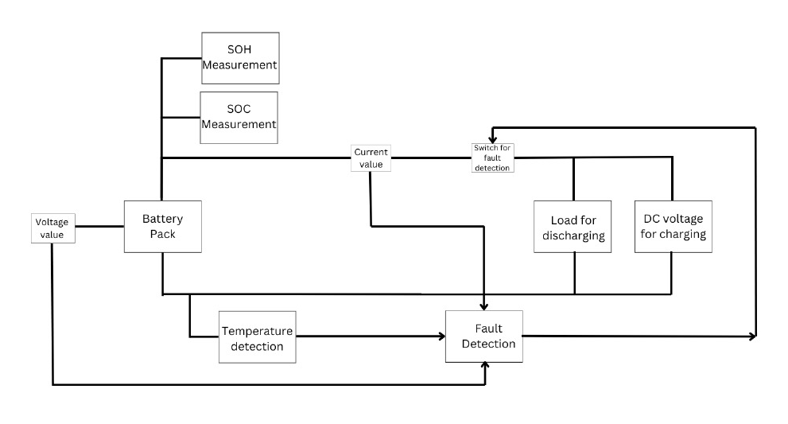

Working Explanation

STATE OF CHARGE (SOC)
- Definition: SOC represents the remaining charge in the battery as a percentage of its maximum capacity. It is calculated dynamically based on current flow.
- Formula: SOC = SOC_{initial}​−Q_{capacity​1}​∫(I_{discharge​d})t
- Components:
  - Current Sensor: Measures the current flowing into or out of the battery.
  - Integrator: Accumulates the current over time to calculate the remaining charge (Q).
  - Subtractor and Gain Blocks: For the calculation as per the formula.
  - Saturation Block: Ensures SOC is constrained between 0% and 100%.
  - Scope: To display the SOC in form of graph with respect to time
- Behaviour:
  - During discharge, SOC decreases as the battery supplies current to the load.
  - During charging, SOC increases as the battery receives current from the charging source.
  - SOC remains at 0% when the battery is fully discharged due to the saturation block.

STATE OF HEALTH (SOH)
- SOH Definition: SOH represents the health status of the battery as a percentage of its nominal capacity. It reflects the aging and degradation of the battery.
- Formula: SOH=Q_{nominal}/​Q_{available}​​×100
- Components:
  - Constant Block: Represents the nominal capacity of the battery.
  - Ramp Block: Simulates the gradual degradation of the battery's capacity over time. The slope of the ramp represents the rate of capacity loss per unit time.
  - Division Block: Divides the current capacity by the nominal capacity to calculate SOH.
  - Gain Block: Converts the SOH value to a percentage by multiplying the result by 100.
  - Saturation Block: Ensures SOH is constrained between 0% and 100%.
  - Scope: To display the SOH in form of graph with respect to time

- Behaviour:
  - As the battery ages, the Ramp Block simulates a decrease in capacity over time.
  - SOH decreases dynamically to reflect the declining health of the battery.

TEMPERATURE MEASUREMENT
- Purpose: The battery's temperature is calculated based on the energy dissipated due to its internal resistance and the current flow.
- Components:
- Product Block: Calculates power dissipation.
- Constant Block: Internal resistance of the battery pack.
- Integrator Block: Integrates the power dissipation over time to compute the temperature rise in the battery.
- Adder Block: Adds the ambient temperature to the computed temperature rise to get the total temperature.
- Behaviour:
  - As the current increases, the heat dissipation rises, causing the battery temperature to increase dynamically.
  - The temperature stabilizes when the current decreases or stops.

VOLTAGE MEASUREMENT
- Purpose: The individual cell voltages and the overall pack voltage are monitored for fault detection and system performance evaluation.
- Components:
- Voltage Sensor Block: Measures the voltage across each individual cell and across the battery pack.

CURRENT MEASUREMENT
- Purpose: Current across the battery pack is measured to monitor fault detection and system performance evaluation.
- Components:
- Current Sensor Block: Measures the current when connected in series with the battery pack.

FAULT DETECTION
- Purpose: Fault detection ensures the safe operation of the battery by identifying overvoltage, overcurrent, and temperature abnormalities and taking corrective actions.
- Components:
- Relational Operators: Compare system parameters (voltage, current, and temperature) to predefined thresholds. Generate fault signals when these thresholds are exceeded.
- Logic Gates: Combine multiple fault signals using OR gates.
- Switch: Disconnect the battery when a fault signal is triggered.
- Flip-Flop: Acts as memory block to store fault value and therefore preventing fault detection from oscillating.
- Fault Scenarios:
  - Over voltage Detection: Each cell's voltage is compared to an overvoltage threshold.
  - Over current Detection: The current through the battery is compared to a maximum allowable current.
  - Over temperature Detection: The battery temperature is compared to a safe limit.
- Behaviour:
  - Fault detection detects the fault and disconnects the battery pack from the circuit hence stopping the flow of current.

Images of the Model

- NO FAULT:
- Load=3 ohm
- Initial SOC = 90 %
- Stop time = 10000 sec

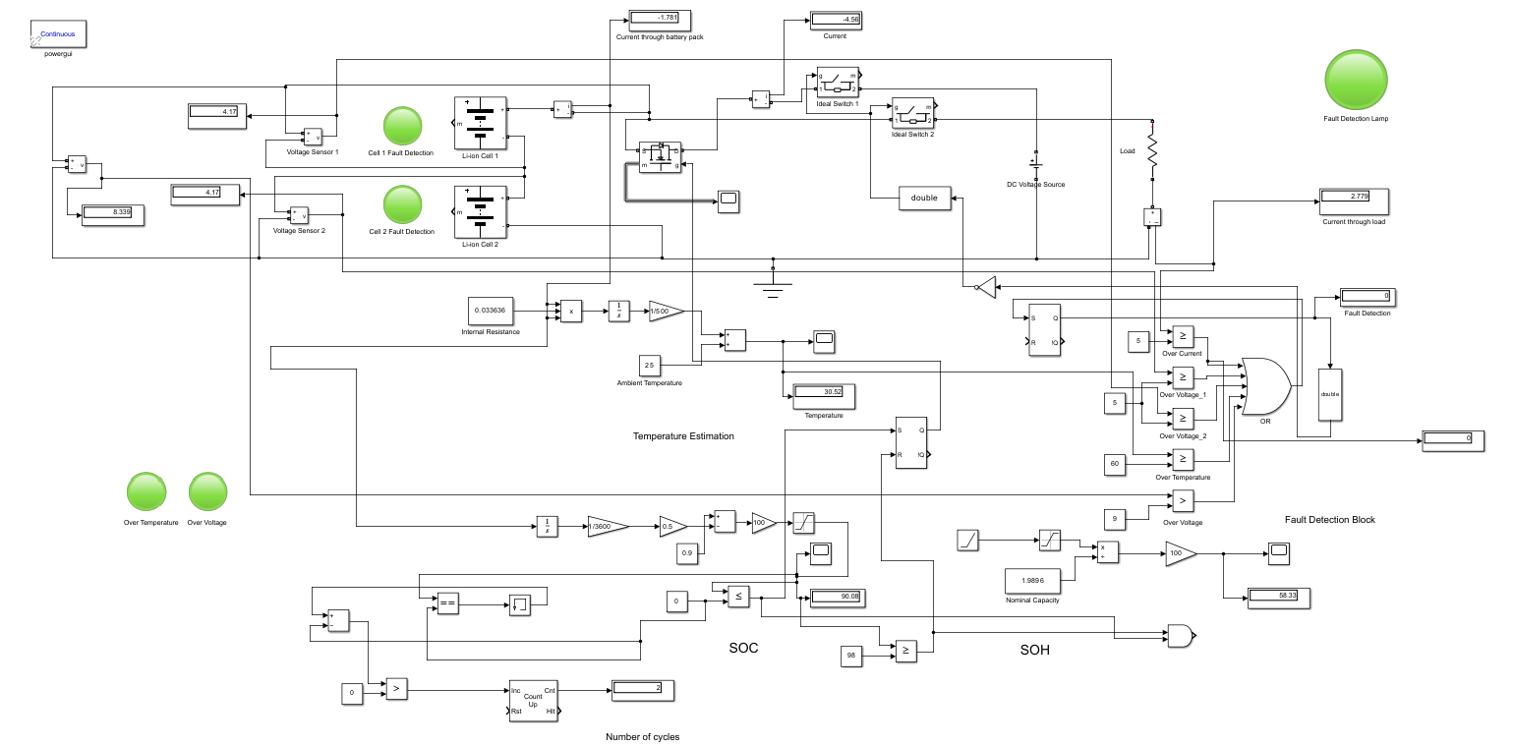

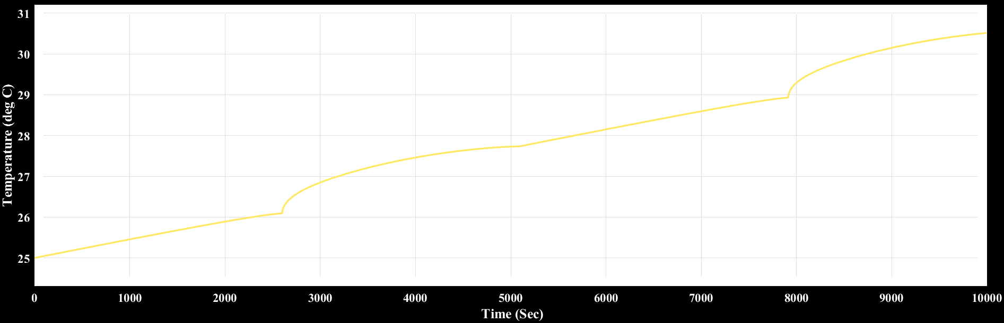
Temperature of battery pack v/s time graph through scope

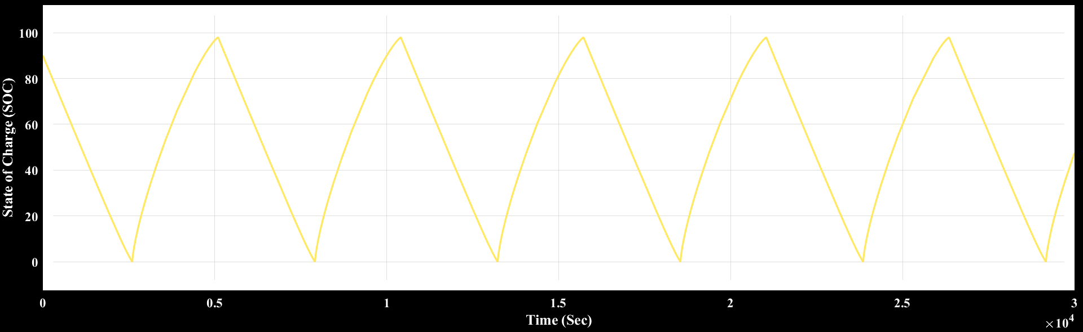
SOC of battery pack v/s time graph through scope

- Stop time = 30000 sec
- Number of cycles=6
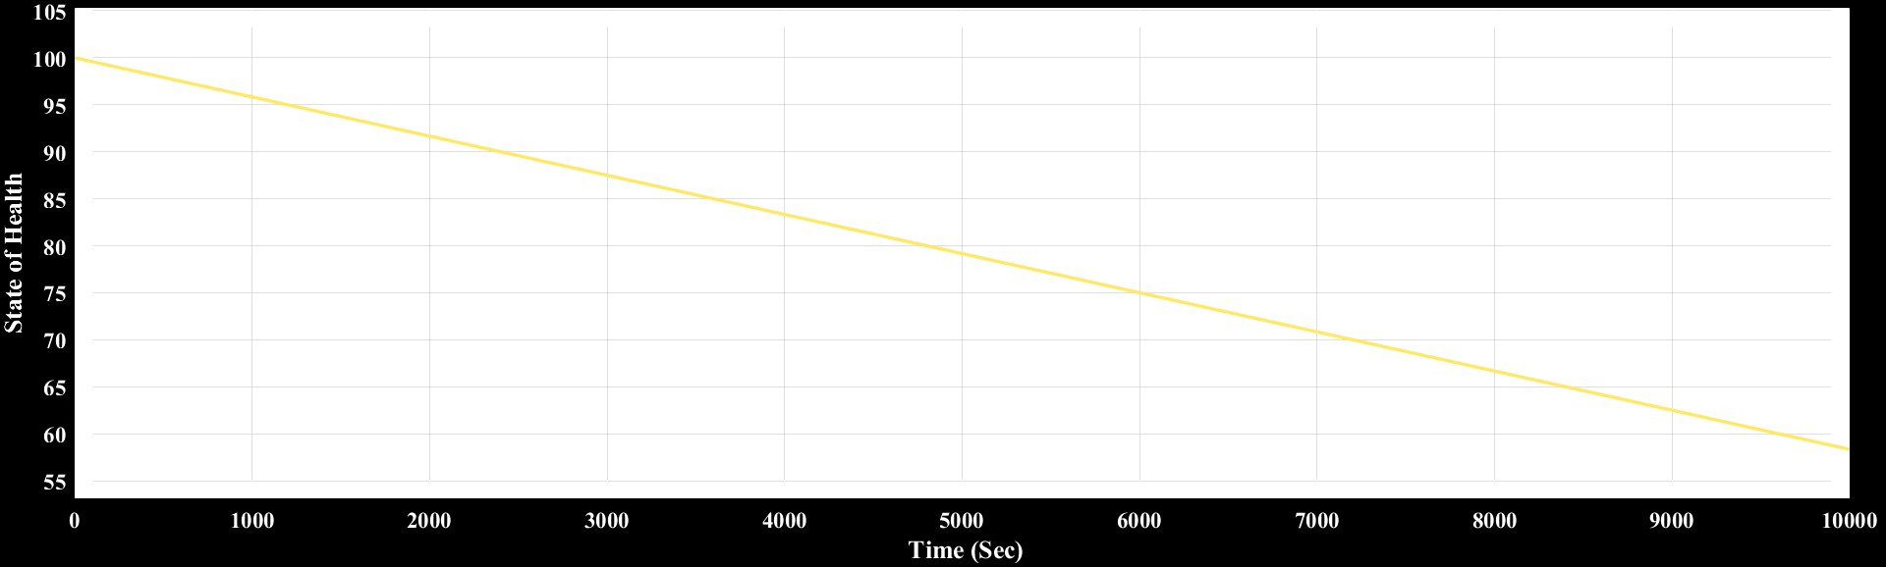
SOH of battery pack v/s time graph through scope

- OVER CURRENT:

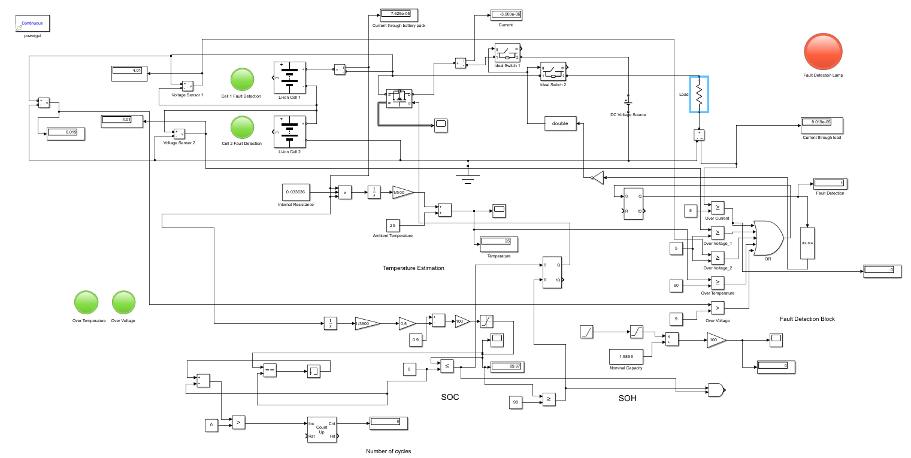

- OVER VOLTAGE:
(DC Voltage Source 1 and Diode 1 are added for simulation purpose)

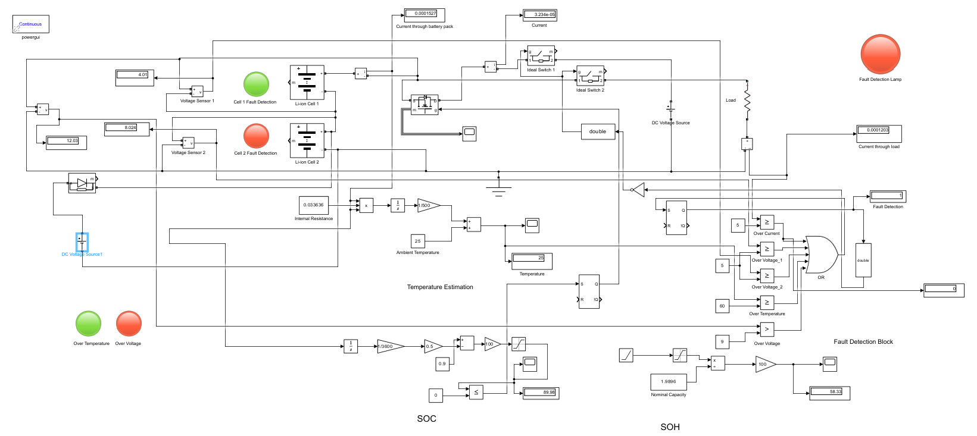

- OVER TEMPERATURE:

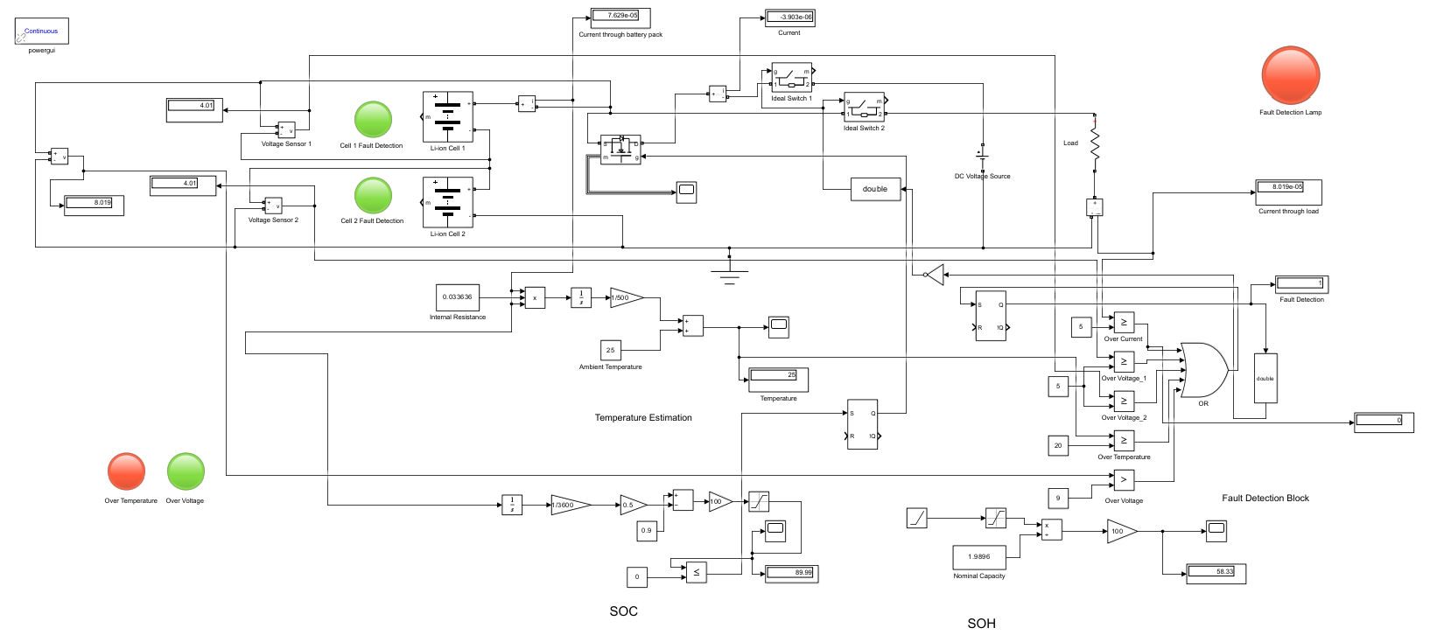

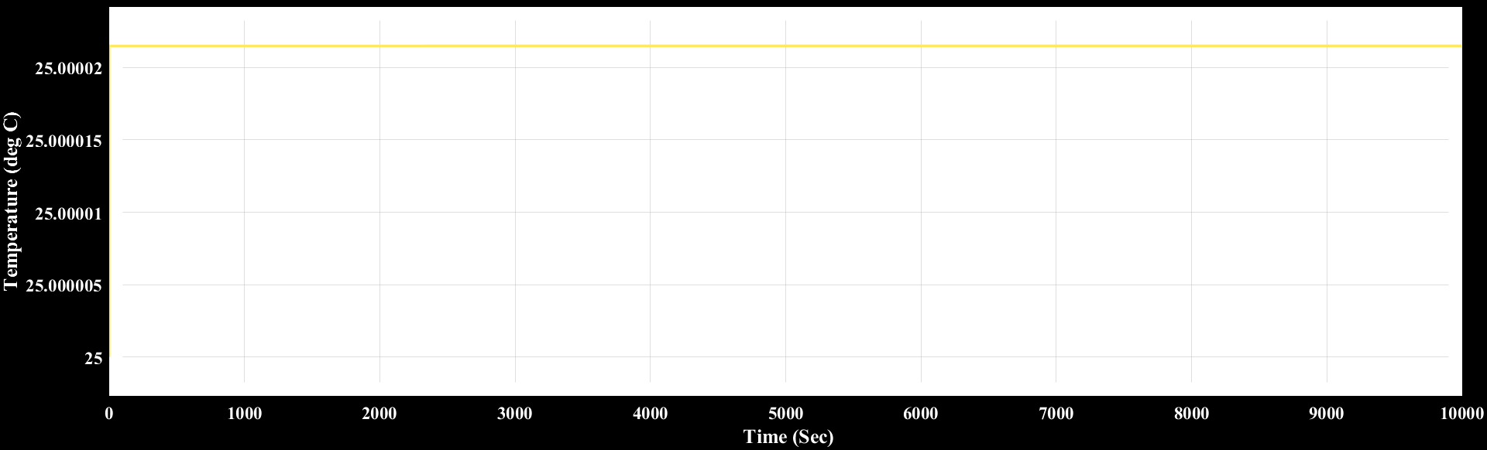
Temperature of battery pack v/s time graph through scope

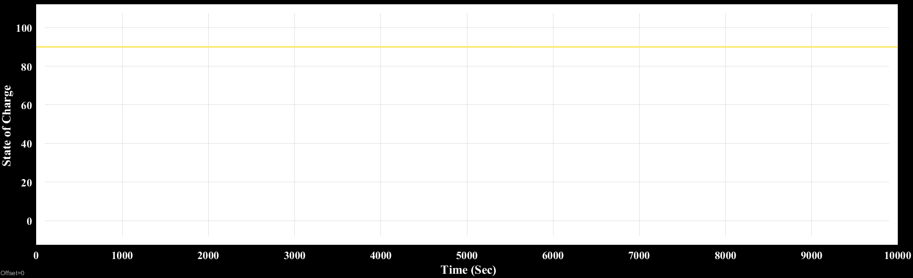
SOC of battery pack v/s time graph through scope

Conclusion

- Comprehensive Integration:
  - The project successfully integrates critical components of a battery management system, including SOC and SOH calculations, fault detection, and temperature monitoring, into a single unified Simulink model.
- Effective Fault Detection:
  - The model demonstrates the ability to detect overvoltage, overcurrent, and overheating conditions, ensuring safe battery operation by dynamically isolating faults and triggering appropriate responses.
- Real-Time Monitoring:
  - Real-time display and visualization of battery parameters, including cell voltage, pack voltage, current, SOC, SOH, and temperature, enhance the system’s monitoring and diagnostic capabilities.
- Temperature Control and Safety:
  - The integration of temperature monitoring ensures that the battery operates within safe thermal limits, with provisions to trigger cooling mechanisms or isolate the battery in case of overheating.
- Charge/Discharge Cycle Tracking:
- The model counts and records charge/discharge cycles, providing valuable data for monitoring battery wear, performance, and lifespan.
- Dynamic Response Mechanism:
  - The system’s dynamic response to changing operational conditions minimizes risks, such as overcharging or deep discharging, and ensures optimal performance and safety.
- Fault Logging and Diagnostics:
  - The inclusion of fault logging mechanisms enables detailed analysis of fault occurrences, assisting in diagnostics and improving system reliability.
- User-Friendly Interface:
  - The use of clear indicators and text-based outputs (e.g., "Battery 1 Overvoltage") provides a user-friendly interface for monitoring and troubleshooting.
- Practical Applications:
  - The project’s focus on safety and efficiency makes it highly applicable to modern technologies, including electric vehicles, renewable energy storage systems, and portable electronics.
These enhancements will ensure safer battery operation, minimize risks associated with faults, and improve the overall efficiency and reliability of the battery system. By addressing critical areas such as overvoltage, overcurrent, and temperature management, these solutions provide a robust framework for optimizing battery performance and extending its lifespan.

References

https://in.mathworks.com/discovery/battery-management-system.htmll

https://in.mathworks.com/content/dam/mathworks/white-paper/simulink-bms-development-white-paper.pdf

https://www.researchgate.net/publication/305493866_Fault_detection_design_and_simulation_based_on_battery_modelling

https://ieeexplore.ieee.org/document/7555475

